Building a Maven Project with Jenkins

This section will guide you to:

* Install Maven and create a Maven project
* Create a Jenkins build job to build a Maven project
* Build a Maven project in Jenkins

**Step 1:Install Maven and create a Maven project**

* Open the terminal.
* If you do not have Maven installed already, run the command, ***sudo apt-get install maven***
* Run the command **mvn --version** to verify the installation.
* Run the following command to create a Maven project:

**mvn archetype:generate -DgroupId=com.simplilearn.app**

**-DartifactId=url-check -DarchetypeArtifactId=maven-archetype-quickstart -DarchetypeVersion=1.4 -DinteractiveMode=false**

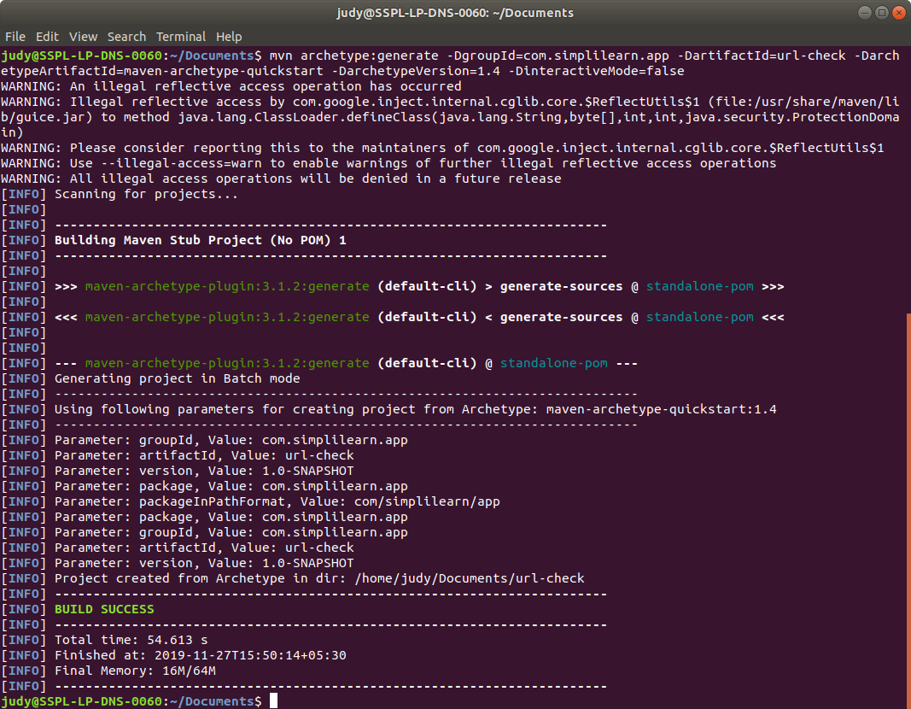

* Once the command is executed, run **cd url-check**
* Inside the project directory, run **ls** and find the *pom.xml* file.
* Run **cd src/main/java/com/simplilearn/app**
* Open App.java in a text editor. Example: nano App.java
* Replace the contents with the below code and save it:

**package com.simplilearn.app;**

**import java.io.IOException;**

**import java.net.HttpURLConnection;**

**import java.net.URL;**

**public class App{**

**public static String checkResponse(String url) throws IOException{**

**HttpURLConnection connection = (HttpURLConnection) new URL(url).openConnection();**

**connection.setRequestMethod("HEAD");**

**int responseCode = connection.getResponseCode();**

**String response = "Success";**

**if (responseCode != 200) {**

**response = "Failed";**

**}**

**return response;**

**}**

**public static void main(String[] args) throws IOException{**

**System.out.println(checkResponse("https:/"+"/samples.openweathermap.org/data/2.5/weather?q=London,uk&appid=b6907d289e10d714a6e88b30761fae22"));**

**}**

**}**

**Step 2: Create a Jenkins build job to build a Maven project**

* Click on *New Item* in the Jenkins dashboard.
* Enter a name for your Maven project.
* Select *Maven Project* as the build job type.

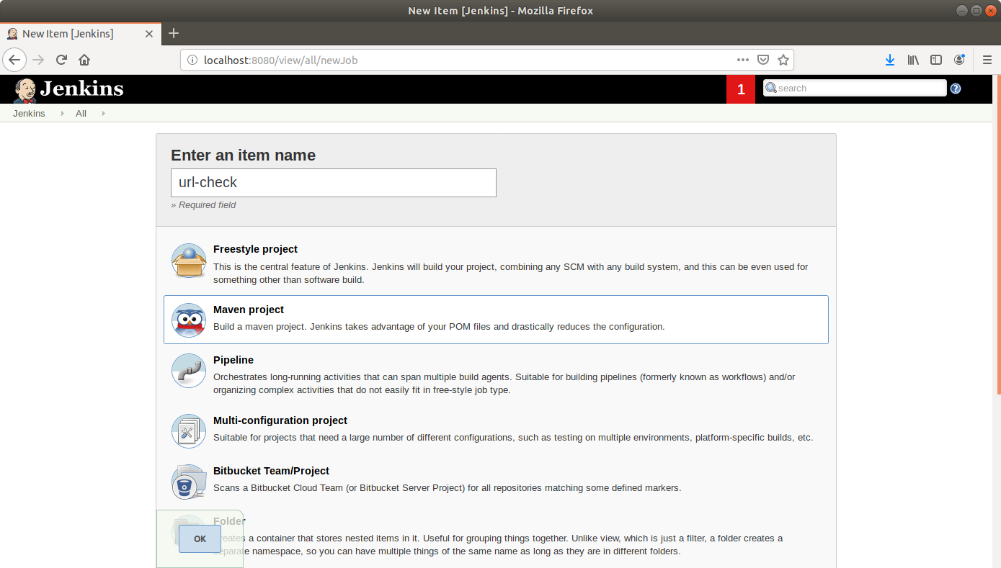

* Click *OK*.
* Keep the defaults and scroll down to the *Build* section.
* Enter the path to the pom.xml.

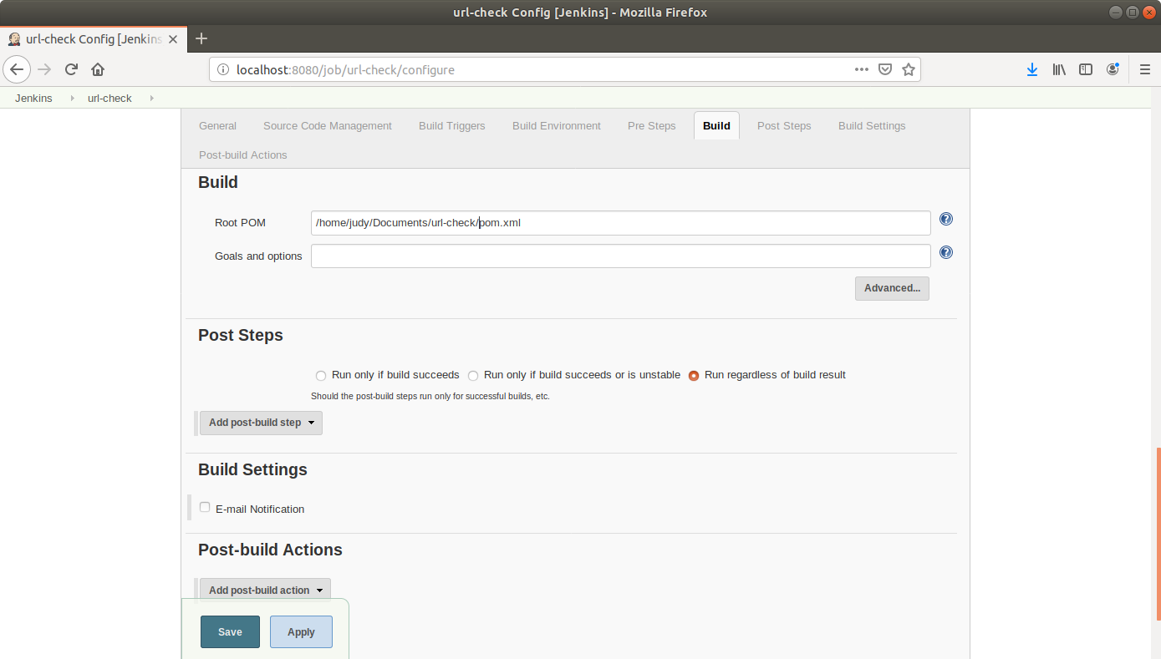

* Scroll down to the *Post-build Steps* section.
* Click on *Add post-build step* and choose *Execute shell* from the drop down menu.

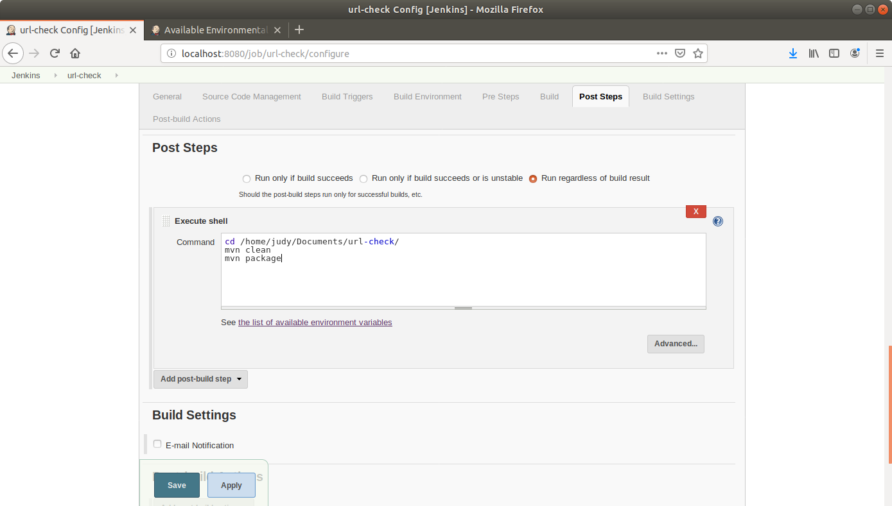

* Enter the commands to navigate to app directory and build the package as shown above.
* Click *Save*.

**Step 2.4.3:** Building a Maven project in Jenkins

* Click on the project name in the Jenkins dashboard.
* Click *Build Now* in the project window. Jenkins will now build your project.

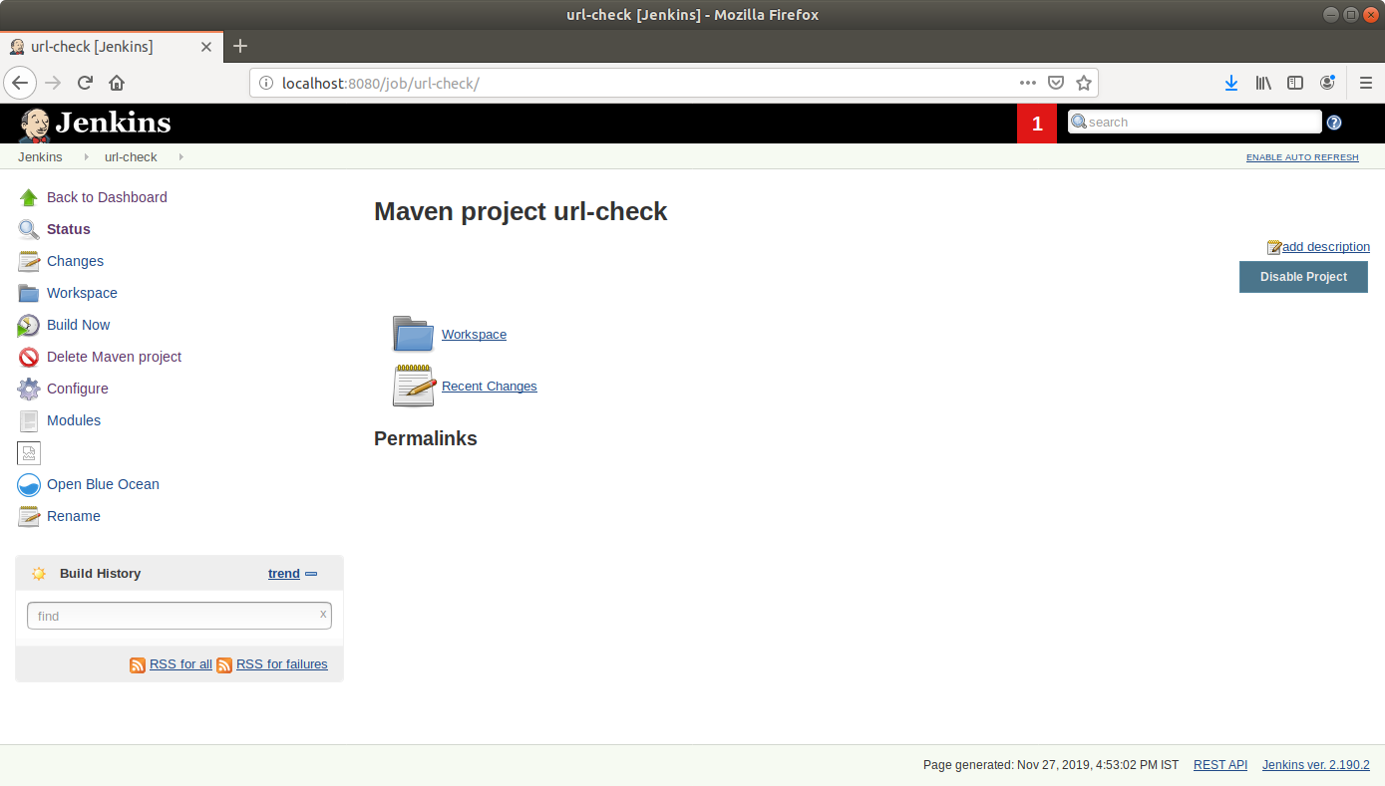

* Click on the *Build History* to view the build results.
* Click on the *Console Output* to view the build logs.

